**Chapter 4**

**Components and Coding**

**4.1 Components**

**1. Microcontroller & Display**

* Arduino (Microcontroller)
* 16x2 LCD Display

**2. Resistors**

* 4kΩ Resistor (For LCD contrast adjustment)
* 1kΩ Resistors (2 units) (For transistor base and LED)

**3. Transistor**

* BC547 (NPN Transistor)

**4. Sensors & Inputs**

* Water Level Sensor (with 5 levels: 100%, 80%, 60%, 40%, 20%)

**5. Indicators & Output**

* Green LED (Motor Indicator)
* Motor (Blower/Fan)

**6. Power & Connections**

* Ground (GND)
* Power Supply (VCC, not explicitly shown but necessary)

**41. Microcontroller & Display**

**4.1.1 Arduino (Microcontroller)**

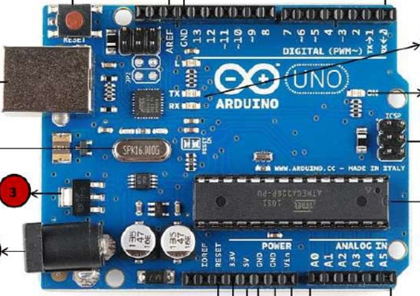

Arduino is an open-source microcontroller board used for electronics projects. It reads input signals from sensors (like the water level sensor in this circuit) and controls outputs (like the LCD display and motor). It processes the data and makes decisions based on programmed instructions.

**4.1.2 Features of Arduino in This Circuit:**

* Reads water level signals from the sensor.
* Displays the water level percentage on the LCD.
* Controls the motor by turning it ON/OFF based on water level conditions.

**4.1.3 16x2 LCD Display**

A 16x2 LCD (Liquid Crystal Display) can display 16 characters per line and has 2 lines. It is commonly used in embedded systems to show output data.

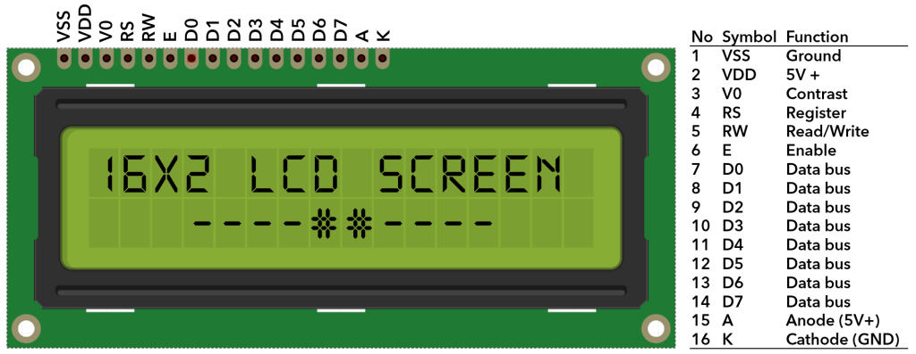

**4.1.4 Features of the LCD in This Circuit:**

* Displays real-time water level readings (e.g., "Water Level: 80%").
* Helps in monitoring the system without needing a computer.
* Connected to the Arduino with multiple pins for data and control.
* Uses a 4kΩ resistor for contrast adjustment.

**4.1.5** **4kΩ Resistor (For LCD contrast adjustment):**

* This resistor is typically used in series with the V0 pin (contrast pin) of an LCD module to control the contrast of the display. Adjusting the contrast is necessary to make the text on the LCD readable under different lighting conditions.

**4.1.6 1kΩ Resistors (2 units) (For transistor base and LED):**

* **For transistor base:** A 1kΩ resistor is often used in series with the base of a transistor to limit the current flowing into the base and to protect the transistor from excessive current. This ensures proper switching behavior for the transistor.
* **For LED:** A 1kΩ resistor is commonly used in series with an LED to limit the current flowing through the LED, preventing it from burning out. The exact value of the resistor depends on the supply voltage and the LED's forward voltage and current rating.
* **Type:** NPN (Negative-Positive-Negative)
* **Main Uses:**
  + **Switching:** The BC547 can act as a switch to control larger currents with a smaller current at its base. It's often used in low-power applications to switch devices like LEDs or motors.
  + **Amplification:** It can also amplify weak electrical signals in circuits like audio amplifiers.
* **Pin 1 (Collector):** The current flows out from the collector. This pin connects to the load or the output part of the circuit.
* **Pin 2 (Base):** The base controls the transistor's switching. A small current flowing into the base allows current to flow from the collector to the emitter.
* **Pin 3 (Emitter):** The current flows into the emitter. This pin connects to ground or the negative side of the circuit.

**Typical Use Cases:**

* **Switching on/off LEDs:** Using a current-limiting resistor (like the 1kΩ you mentioned earlier), the base can be controlled by a microcontroller or any logic circuit to switch on/off the LED.
* **Amplifying signals:** In a common-emitter configuration, the BC547 can amplify small signals, useful in audio circuits.

The **Water Level Sensor** you mentioned, with 5 levels (100%, 80%, 60%, 40%, 20%), is likely a type of analog or digital sensor used to detect the water level in a tank or container. These sensors typically provide different outputs based on the level of water in contact with the sensor, which can then be used to control various devices (such as pumps or alarms).

**4.1.7 Green LED (Motor Indicator):**

* **Purpose:** The green LED is commonly used as an indicator light, often to show that a motor or system is running or operating normally. In your case, it will likely indicate whether the **blower/fan motor** is on or off.
* **Connections:**
  + The LED should be connected in series with a current-limiting resistor (such as the **1kΩ resistor** you mentioned earlier) to avoid damaging the LED.
  + The anode (positive side) connects to the positive voltage supply (such as 5V or 12V depending on your system), while the cathode (negative side) connects to the control circuit, such as a transistor or microcontroller, which can turn it on or off.
* **Usage:** The LED will light up when the motor is running (or the system is active), providing a visual indication to the user. It could be controlled by a transistor or a relay connected to a microcontroller.

**4.1.8 Motor (Blower/Fan):**

* **Purpose:** The motor is used to drive the blower or fan. It will be responsible for creating airflow in a cooling system, exhaust system, or ventilation setup.
* **Control Circuit:**
  + **Transistor or Relay:** The motor will likely require a higher current than what a microcontroller can supply directly. Therefore, a **transistor** (like the **BC547** you mentioned earlier) or a **relay** is used to switch the motor on and off.
  + **Transistor-based Switching:** The base of the **BC547** would be connected to the control signal (like from a microcontroller or sensor), and the emitter would go to ground. The collector would connect to the negative terminal of the motor, with the positive terminal of the motor connected to the supply voltage.
  + **Motor Driver (if needed):** Depending on the type and voltage of the motor, you might also need a dedicated **motor driver circuit** (like an L298N for DC motors or an H-Bridge) to handle the motor's current requirements.

**4.1.8 Ground (GND):**

* **Purpose:** The **ground (GND)** is the reference point for the entire circuit. All components in the system need a common ground connection to ensure that their signals and voltage levels are properly referenced to the same point.
* **Connections:**
  + All components (sensors, motor, LEDs, microcontroller, etc.) should be connected to the **GND pin** on the power supply or microcontroller (e.g., Arduino).
  + The **GND of the power supply** connects to the GND of the microcontroller and other components, ensuring that all parts of the circuit have the same voltage reference.
  + For the **transistor (BC547)**, the **emitter** is connected to the ground (GND), which completes the circuit for the base and collector to work correctly.

**4.1.9 Power Supply (VCC):**

* **Purpose:** The **VCC** (or supply voltage) provides the necessary power to drive all components in the system, including sensors, LEDs, the motor, and the microcontroller.
* **Connections:**
  + **Microcontroller:** The **VCC pin** (usually 5V or 3.3V depending on the microcontroller) connects to the positive rail of your circuit to power the microcontroller and possibly low-power components like sensors or LEDs.
  + **Motor (Blower/Fan):** The motor will likely require a higher voltage (e.g., 12V). So, you'll need a **separate power supply** for the motor. If your motor operates at 12V, then **VCC for the motor** will be connected to a 12V power supply, while the microcontroller and other components use the lower voltage (e.g., 5V or 3.3V).
  + **Transistor (BC547):** The **collector** of the BC547 transistor will connect to the motor, and the **VCC (supply voltage)** for the motor will connect to the motor's positive terminal. The power to the transistor comes from the same supply that powers the motor, ensuring that the transistor can handle the current needed for the motor.

**5 General Connection Summary:**

* **Power Supply (VCC)** is connected to all components that need a power source (like the motor, microcontroller, and sensors).
* **Ground (GND)** should be connected to all components to provide a common reference point.
* Ensure that different voltage requirements (e.g., 5V for the microcontroller and 12V for the motor) are handled correctly, potentially using separate power supplies or voltage regulators.
* **Motor control**: Use a transistor (like **BC547**) or a relay to switch the motor on and off based on input from sensors or the microcontroller.

**Example Setup:**

* **VCC (5V or 12V)**: Powers the microcontroller, sensors, and motor (depending on voltage requirements).
* **GND**: Common ground shared by all components.
* **Motor**: Powered separately by **12V**, controlled through the **transistor (BC547)**.
* **LED**: Connected to **VCC** through a current-limiting resistor, with the cathode to **GND**

**5. code**

#include <LiquidCrystal.h>

int level_1 = A1;

int level_2 = A2;

int level_3 = A3;

int level_4 = A4;

int level_5 = A5;

int pin_motor = 8;

int led = 9;

int a;

int b;

int c;

int d;

int e;

int r; //Water Pump status

int z=100;

LiquidCrystal lcd(2, 3, 4, 5, 6, 7);

void setup()

{

pinMode(level_1,INPUT);

pinMode(level_2,INPUT);

pinMode(level_3,INPUT);

pinMode(level_4,INPUT);

pinMode(level_5,INPUT);

pinMode(pin_motor,OUTPUT);

pinMode(led,OUTPUT);

lcd.begin(16, 2);

}

void loop()

{

r=digitalRead(pin_motor);

a=analogRead(level_1);

b=analogRead(level_2);

c=analogRead(level_3);

d=analogRead(level_4);

e=analogRead(level_5);

lcd.clear();

lcd.setCursor(0,0);

lcd.print("MORY");

//lcd.setCursor(0,1);

//lcd.print("Water Level ");

if(e>z && d>z && c>z && b>z && a>z )

{

digitalWrite(pin_motor,LOW);

lcd.setCursor(0,0);

lcd.print("Tank is 100%FULL");

digitalWrite(led,HIGH);

delay(500);

digitalWrite(led,LOW);

delay(500);

{

lcd.setCursor(0,0);

lcd.print("Tank is 80% FULL");

}

else if(e<z && d<z && c>z && b>z && a>z )

{

lcd.setCursor(0,0);

lcd.print("Tank is 60% FULL");

}

else if(e<z && d<z && c<z && b>z && a>z )

{

lcd.setCursor(0,0);

lcd.print("Tank is 40% FULL ");

}

else if(e<z && d<z && c<z && b<z && a>z )

{

lcd.setCursor(0,0);

lcd.print("Tank is 20% FULL");

}

else if(e<z && d<z && c<z && b<z && a<z )

{

digitalWrite(pin_motor,HIGH);

lcd.setCursor(0,0);

lcd.print("Tank is EMPTY ");

}

if(r==LOW)

{

lcd.setCursor(0,1);

lcd.print("Pump is (OFF) ");

}

else

{

lcd.setCursor(0,1);

lcd.print("Pump is (ON) ");

}

delay(100);

lcd.clear();

}